FOR IMMEDIATE RELEASE
Sept. 6, 2016
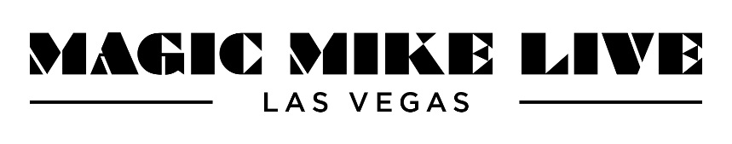
TICKETS ON SALE NOW FOR MAGIC MIKE LIVE LAS VEGAS DEBUTING AT HARD ROCK HOTEL & CASINO ON MARCH 30, 2017

Las Vegas – As announced today by Channing Tatum on the Season 14 premiere of "Ellen," tickets are now on sale for the highly anticipated MAGIC MIKE LIVE LAS VEGAS. Tatum appeared on "Ellen" to share the news and to give the audience a special preview of MAGIC MIKE LIVE LAS VEGAS with some of the dancers from the show.

Oprah Winfrey joined the festivities as well with a cameo in Ellen's "Magic Michelle," where she along with Jenna Dewan-Tatum, Chrissy Teigen and Olivia Munn created their own female revue. The elated audience was then surprised with 2 tickets each to MAGIC MIKE LIVE and a 2 night/ 3 day stay at The Hard Rock Hotel & Casino.
Starting today, fans everywhere can now purchase their own tickets to experience MAGIC MIKE LIVE LAS VEGAS through ticketmaster.com or magicmikelivelasvegas.com, or by phone at 800.745.3000.

Beginning with preview performances on March 30, MAGIC MIKE LIVE LAS VEGAS will recreate the mythic Club Domina as a cabaret nightclub space inside Hard Rock that is being fully redesigned to capture the magnetism of the Magic Mike franchise. The state-of-the-art venue is designed with the capabilities to house a show that features thirteen of the hottest and most talented men in the country performing in front of, behind, above and all around the audience.

Conceived by Tatum, the show will be co-directed by Tatum and film franchise choreographer Alison Faulk. Produced by Free Association, in association with United Talent Agency, Aloris Entertainment, Warner Bros., BASE Entertainment and Hard Rock Hotel & Casino, MAGIC MIKE LIVE LAS VEGAS is built to give women an immersive, first-class entertainment experience. With sexy and daring themed dance routines punctuated by one-of-a-kind acts from a wildly diverse cast of performers, MAGIC MIKE LIVE LAS VEGAS is a 360-degree dance and acrobatic strip tease spectacular.

MAGIC MIKE LIVE LAS VEGAS is being created for guests 18 and older. Preview performances at Hard Rock Hotel & Casino in Las Vegas begin March 30, 2017. MAGIC MIKE LIVE LAS VEGAS will be performed Wednesdays through Sundays at 7:30pm and 10:00pm. Ticket prices start at $49 and are available by phone at 800.745.3000, or online at Ticketmaster.com or MagicMikeLiveLasVegas.com. A $40 VIP Meet & Greet add-on is available with any ticket purchase and includes a meet & greet with the cast and a souvenir photo. For Group orders of 10 or more, call 1-866-633-0195 or email Sales@BASEentertainment.com.
###

Media Contacts
Kate Whiteley, Kirvin Doak Communications
kwhiteley@kirvindoak.com
702-737-3100

About Hard Rock Hotel & Casino
Hard Rock Hotel & Casino is Las Vegas’ off-strip playground, just minutes from McCarran International Airport. Built in 1995, the property completed a $700 million expansion in 2010. Hard Rock Hotel & Casino offers an energetic entertainment and gaming experience with services and amenities associated with a boutique luxury resort hotel. The property is known for its innovative nightlife and music scene where acts such as The Rolling Stones, Bon Jovi and Paul McCartney have all performed. Features of the property include 1,504 rooms and suites; a 60,000 square foot casino; 80,000 square feet of flexible meeting and convention space; Reliquary Water Sanctuary, Spa & Salon; a 4.8 acre tropical pool paradise; world-class dining; renowned live music/entertainment venues; more than $4 million in rare music memorabilia and a variety of on-trend retail outlets.

About BASE Entertainment
BASE Entertainment develops, produces, and manages intellectual properties and venues for live entertainment in North America and internationally from offices in New York, Houston, Las Vegas, and Singapore. In addition to Magic Mike Live Las Vegas at the Hard Rock, BASE's current productions in Las Vegas include Mat Franco – Magic Reinvented Nightly at the Linq, Absinthe at Caesars Palace, Rock of Ages at The Rio, Puppet Up at the Venetian, Jersey Boys at Paris, and Million Dollar Quartet at Harrah’s. In addition, BASE operates the Showroom at Planet Hollywood Resort & Casino and the theaters at Marina Bay Sands in Singapore. BASE also produces museum quality touring and residency exhibitions including Sea Monsters Revealed and Battle for Texas: The Experience. BASE Entertainment’s founders and partners include industry veterans Brian Becker and Scott Zeiger, and Beverly Hills-based private equity firm Clarity Partners. For more information please visit BASEentertainment.com.

