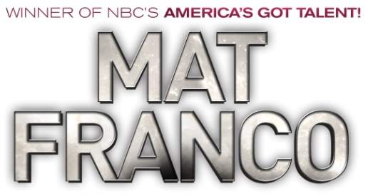

MAT FRANCO – MAGIC REINVENTED NIGHTLY NOW CAPTIVATING AUDIENCES AT THE LINQ HOTEL & CASINO IN LAS VEGAS

LAS VEGAS – Season Nine winner of NBC’s America’s Got Talent, magician Mat Franco continues to captivate and amaze audiences in MAGIC REINVENTED NIGHTLY at The LINQ Hotel & Casino in Las Vegas with a fun and feel-good twist on magic that defies all expectations.

Fresh from his triumphant win on the country’s largest talent competition and his follow up primetime TV special, Mat Franco’s Got Magic in 2015, Mat presents an unparalleled production and innovative approach to magic-making that’s driven by his passion and imagination. With his signature brand of breezy humor, Mat mixes his amazingly inventive and stunning magic with crowd-guided improv, creating a once-in-a-lifetime adventure that’s unique and unforgettable to each audience.

Named “Best Strip Show” by Las Vegas Weekly, MAT FRANCO – MAGIC REINVENTED NIGHTLY opened in August 2015 to rave reviews by critics and audiences alike. Vegas.com hails the production as “90 minutes of mind-bending magic,” and Las Vegas Sun has dubbed Mat as “a master magician for the millennial generation.”

MAT FRANCO – MAGIC REINVENTED NIGHTLY performs Thursday - Friday at 7 p.m, Saturday at 4 p.m. and 7 p.m., Sunday – Tuesday at 7 p.m. and is dark on Wednesday. The performance schedule is subject to change without notice. Ticket prices start at $39 plus all applicable taxes and fees and a VIP Experience is available with a $50 upgrade on any section plus all applicable fees, per person. The VIP Experience includes a personal meet & greet and photo with Mat Franco directly following the performance, a VIP laminate, a signed keepsake souvenir and a complimentary beverage; subject to availability and schedule change. Tickets can be purchased online at MatFranco.com, by calling 702-777-2782 or in-person at The LINQ Theater box office. For additional information on MAT FRANCO – MAGIC REINVENTED NIGHTLY, visit MatFranco.com and connect with the show on Facebook, Twitter and Instagram - @MagicReinvented.

###

MEDIA CONTACT:
Erica Benken / Thomas Judd
ebenken@kirvindoak.com / tjudd@kirvindoak.com
Kirvin Doak Communications, 702.737.3100

About The LINQ Hotel & Casino:
As the social hub at the center of the Las Vegas Strip, The LINQ Hotel & Casino - voted “Best New Hotel” by Vegas Chatter - offers a total of 2,253 newly renovated rooms designed by Elkus Manfredi Architects including 244 suites with two unique penthouses and 25 cabana suites. Positioned between Flamingo Las Vegas and Harrah’s Las Vegas, guests experience one distinctive destination with The LINQ Promenade and High Roller observation wheel. Enjoy celebrated chef restaurant Guy Fieri’s Vegas Kitchen & Bar, Hash House a Go Go and direct access to O’Shea’s Casino, Off The Strip and Chayo Mexican Kitchen + Tequila Bar. Entertainment and nightlife experiences include 3535, a unique take on the lobby bar, TAG Sports Bar, as well as popular entertainers Mat Franco, Jeff Civillico and Frank Marino’s “Divas Las Vegas” in the Showroom. The LINQ Hotel & Casino offers a re-imagined pool deck featuring two pools, the new 15,000-square foot Spa at The LINQ and fitness center, additional retail, as well as meeting space. For more information visit TheLINQ.com, like us on Facebook or follow us on Twitter.

