**FOR IMMEDIATE RELEASE**

Sept. 9, 2016

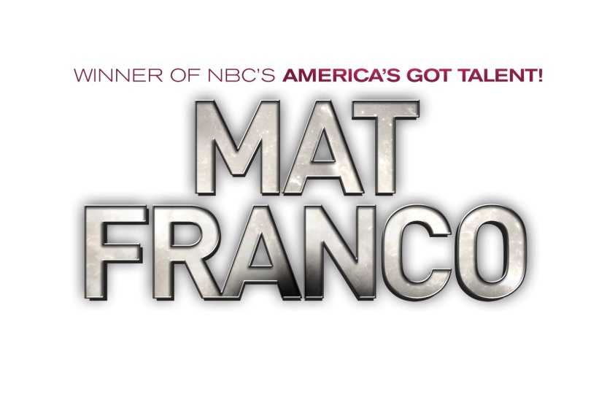

**MAGICIAN MAT FRANCO MAKES LARGE DONATION OF NEEDED SUPPLIES**

**TO THE ANIMAL FOUNDATION IN CELEBRATION OF FIRST ANNIVERSARY**

**OF *MAGIC REINVENTED NIGHTLY,* SEPT. 9**

*Supply Drive Raises More than $5,000 in Animal Care Supplies, $1,680 in Monetary Donations*

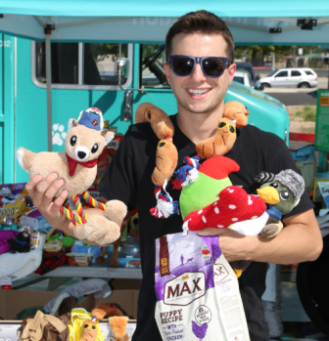  

Today (Sept. 9, 2016), magician **Mat Franco** presented [**The Animal Foundation**](https://animalfoundation.com/) with a donation of more than $5,000 in much-needed animal care supplies and $1,680 in monetary gifts to benefit the more than 30,000 animals that are cared for annually by the organization. The master of sleight-of-hand met with representatives from the state’s largest open-admission animal shelter for a tour of the eight-acre property and to make the sizable donation, which was the product of a month-long, community-driven supply drive held in partnership with[**Sunny 106.5 FM**](http://sunny1065.iheart.com/)and [**Petco**](http://www.petco.com) in celebration of a tremendous year of continued success and sold-out audiences at [***MAGIC REINVENTED NIGHTLY***](http://www.matfranco.com/) at The LINQ Hotel & Casino.

“Unlike humans, animals don’t have a voice to speak for themselves,” shared Franco. “So I was excited to find a way to help out our furry friends while thanking the community who’s been so supportive of our show in the process.”

Throughout the month of August, the young magician offered fans and community members the opportunity to receive a complimentary ticket voucher to experience ***MAGIC REINVENTED NIGHTLY*** in return for the donation of a minimum of $10 worth of items from The Animal Foundation’s wish list, which was comprised of blankets, collars, harnesses, leashes, dog and cat treats and toys, and more.

“We are grateful for Mat’s generosity in organizing this donation drive on our behalf, and the community for the overwhelming number of donations," said Elysia Sheldon, events manager at The Animal Foundation. "These donations will not only help the animals at The Animal Foundation, but also pets in under-served areas of the community.”

The Animal Foundation houses and provides care for thousands of lost, unwanted, neglected and abandoned animals of varying species each year, and is in constant need of supplies to continue providing top-quality care for its animals. To learn more about the needs of The Animal Foundation, visit [AnimalFoundation.com](http://www.animalfoundation.com).

Named “Best Strip Show” by *Las Vegas Weekly,* ***MAGIC REINVENTED NIGHTLY*** opened in August 2015 to rave reviews by critics and audiences alike. *Vegas.com* hails the production as “90 minutes of mind-bending magic,” and *Las Vegas Sun* has dubbed Franco as “a master magician for the millennial generation.” For tickets and more information, visit [MatFranco.com](http://www.matfranco.com) and connect with the show on [Facebook](http://www.facebook.com/magicreinvented), [Twitter](http://www.twitter.com/magicreinvented) and [Instagram](http://www.instagram.com/magicreinvented) - @MagicReinvented.

**For a link to select images from the donation presentation, please click here:**

[**https://spaces.hightail.com/receive/Et9Fx**](https://spaces.hightail.com/receive/Et9Fx)

**Courtesy: Samuel Boeres**

**For broadcast quality b-roll of MAT FRANCO – MAGIC REINVENTED NIGHTLY, please click here:**

[**https://spaces.hightail.com/receive/mLn5Y**](https://spaces.hightail.com/receive/mLn5Y)

**Courtesy: MAT FRANCO – MAGIC REINVENTED NIGHTLY**

**About MAT FRANCO – MAGIC REINVENTED NIGHTLY**

Mat Franco takes the stage in **MAGIC REINVENTED NIGHTLY** at The LINQ Hotel & Casino with a fun and feel-good twist on magic that defies all expectations. Fresh from his triumphant win on *America's Got Talent* and his follow up primetime special, *Mat Franco’s Got Magic* on NBC in 2015, Mat presents an unparalleled production and innovative approach to magic-making that’s driven by his passion and imagination. With his signature brand of breezy humor, Mat mixes his amazingly inventive and stunning magic with crowd-guided improv, creating a once-in-a-lifetime adventure that’s unique and unforgettable to each audience. For more information, visit [MatFranco.com](http://www.matfranco.com) and connect with the show on [Facebook](http://www.facebook.com/magicreinvented), [Twitter](http://www.twitter.com/magicreinvented) and [Instagram](http://www.instagram.com/magicreinvented) - @MagicReinvented.

**About The LINQ Hotel & Casino**

As the social hub at the center of the Las Vegas Strip, The LINQ Hotel & Casino – voted “Best New Hotel” by *Vegas Chatter* – offers a total of 2,253 newly renovated rooms including 244 [suites](https://www.caesars.com/anthology-suites) with two unique penthouses and 25 cabana rooms with direct access to the pool. Positioned between Flamingo Las Vegas and Harrah’s Las Vegas, guests experience one distinctive destination with The LINQ Promenade and High Roller, the world’s tallest observation wheel. Designed with the modern traveler in mind, the resort launched the first fully integrated self check-in program on the Las Vegas Strip in 2015. Enjoy celebrated chef restaurant Guy Fieri’s Vegas Kitchen & Bar, voted “Best Gastropub of 2015” by the readers of the *Las Vegas Review-Journal*, award-winning Hash House a Go Go and direct access to O’Sheas Casino, Off The Strip and Chayo Mexican Kitchen + Tequila Bar. Entertainment and nightlife experiences include 3535, a unique take on the lobby bar, TAG Sports Bar, a state-of-the-art gaming lounge, as well as popular entertainers such as Frank Marino’s “Divas Las Vegas” and magician Mat Franco, “America’s Got Talent” Season Nine winner. The LINQ Hotel & Casino offers a reimagined pool deck featuring two pools, the new 15,000-square-foot Spa at The LINQ and fitness center, The Silver Sky Chapel for intimate weddings and 63,000 square feet of meeting space. For more information, please visit [TheLINQ.com](http://www.caesars.com/thelinq.com/) or the Caesars Entertainment Las Vegas [media room](http://caesarslasvegas.mediaroom.com/). Find The LINQ on [Facebook](http://facebook.com/TheLINQ) and follow on [Twitter](http://twitter.com/TheLINQ) and [Instagram](https://www.instagram.com/thelinq/?hl=en).

###

**Media Contacts:**

Erica Benken / Thomas Judd

[ebenken@kirvindoak.com](mailto:ebenken@kirvindoak.com) / [tjudd@kirvindoak.com](mailto:tjudd@kirvindoak.com)

Kirvin Doak Communications, 702-737-3100http://t.sidekickopen29.com/e1t/o/5/f18dQhb0S7ks8dDMPbW2n0x6l2B9gXrN7sKj6v5dr1HW4Xrmkd5v0vmxN4X9VHbd3_yKW3D8s8f1k1H6H0?si=5931173908316160&pi=98c7e05f-cc0c-431c-925b-5256e0337631